SILo: Sistem Informasi Logistik

Software Requirements Specification

For <Subsystem or Feature>

Version <1.0>

Revision History

|  |  |  |  |
| --- | --- | --- | --- |
| **Date** | **Version** | **Description** | **Author** |
| 01 Okt 2020 | 1.0 | Initiation | Daniel Siahaan |
|  |  |  |  |
|  |  |  |  |
|  |  |  |  |

Table of Contents

1. Introduction 4

1.1 Purpose 4

1.2 Scope 4

1.3 Definitions, Acronyms and Abbreviations 4

1.4 References 4

1.5 Overview 4

2. Overall Description 4

2.1 Scenario 4

2.2 Context Diagram 5

3. Specific Requirements 5

3.1 Functionality 5

3.2 Non-Functionality 6

4. Supporting Information 6

Software Requirements Specification

# Introduction

This section provides an overview of the entire document. It includes description about the purpose, scope, definitions, acronyms, abbreviations, references and overview of the document.

## Purpose

The purpose of this document is to describe the basic needs of end users that the system should provide and attributes, properties, constraints, and qualities that the system should meet in order the system to achieve the goal of the system, i.e. to enable software engineer to analyze the dependency between requirements given the artifacts and deliverables of the project.

The document also describes the external behavior of the application or subsystem identified. It also describes nonfunctional requirements, design constraints and other factors necessary to provide a complete and comprehensive description of the requirements for the software.

## Scope

This document covers minimum functionalities required by key end-users in the system of Logistic Information System (Sistem Informasi Logistik, SILo). There are three classes of end-users covers in this document, i.e. booker, cashier, and warehouse staff. The booker is an administrative staff who is responsible on maintaining the master data of the items. The cahsier is an administrative staff who is responsible on submitting a delivery note. This delivery note allow assignee to take out designated items to be taken from the warehouse. The warehouse staff is a staff at the warehouse section who is responsible on maintaining inbound logistic and outbound logistic. Any inbound logistics should be accompanied by an invoice. On the other hand, any outbound logistics should be accompanied by delivery note

## Definitions, Acronyms and Abbreviations

n.a.

## References

UCSpec-01 Use Case Specification Document of ‘Lihat Daftar Item’

UCSpec-02 Use Case Specification Document of ‘Lihat Surat Jalan’

UCSpec-03 Use Case Specification Document of ‘Buat Surat Jalan’

UCSpec-04 Use Case Specification Document of ‘Lihat Daftar SP’

## Overview

The rest of the document is organized as follows. The second section explain the overall description of the system to be implemented, i.e. the scenario and the context diagram of the system. The last section describes the list of all functional and non-functional requirements.

# Overall Description

## Scenario

That Monday morning, Ratna was visited by Yakub who would like to buy two thermogun devices from PT SLS. After completing the payment, Ratna printed a receipt and handed it over to Yakub. Along with the receipt, Ratna create a respective delivery note via the SILo. Then, Ratna sent Yakub to the warehouse. Yakub immediately went to the warehouse. He met Rivo, the warehouse staff, and shown the receipt. Rivo checked the invoice number for the corresponding delivery note via the SILo. He found it and change the status to ‘preparing’. He prepared the requested items according to the delivery note. He asked Yakub to check the prepared items and digitally sign the delivery note. The status changed to ‘completed’. After everything was done, Yakub left the office with his purchased items.

Not long after Yakub left, Mark arrived at the warehouse. He is the expedition officer. He delivered a package to PT SLS. Rivo received the package. He opened SILo and search for corresponding purchase order by entering the package number. After finding it, he cross-checked the items in the package against changed the status. He changed the status to ‘confirmed’.

## Context Diagram

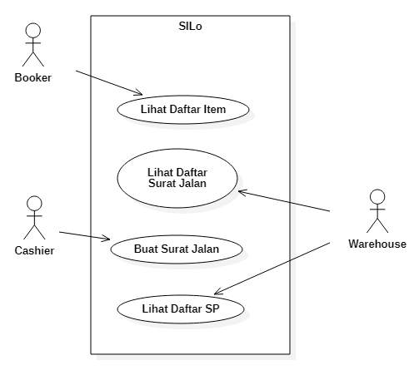

|  |  |  |
| --- | --- | --- |
| ID | UC Name | UC Description |
| UC01 | Lihat Daftar Item | Booker views the list of items in the catalog for managing the items. |
| UC02 | Lihat Daftar Surat Jalan | Warehouse views the list of delivery notes for managing outbound logistics. |
| UC03 | Buat Surat Jalan | Cashier create a delivery note based on invoice. |
| UC04 | Liht Daftar SP | Warehouse views the list of purchase orders for managing inbound logistics. |

# Specific Requirements

This section contains all the software requirements to a level of detail sufficient to enable designers to design a system to satisfy those requirements, and testers to test that the system satisfies those requirements.

## Functionality

|  |  |  |  |
| --- | --- | --- | --- |
| ID | Statement | UC | Priority |
|  |  |  |  |
|  |  |  |  |
|  |  |  |  |
|  |  |  |  |
|  |  |  |  |
|  |  |  |  |
|  |  |  |  |
|  |  |  |  |
|  |  |  |  |
|  |  |  |  |

## Non-Functionality

|  |  |  |  |  |
| --- | --- | --- | --- | --- |
| ID | Statement | Quality | UC | Priority |
|  |  |  |  |  |
|  |  |  |  |  |
|  |  |  |  |  |
|  |  |  |  |  |
|  |  |  |  |  |

# Supporting Information

[The supporting information makes the SRS easier to use. It includes: a) Table of contents, b) Index, c) Appendices. These may include use-case storyboards or user-interface prototypes. When appendices are included, the SRS should explicitly state whether or not the appendices are to be considered part of the requirements.]